Introduction to comparative Mythology

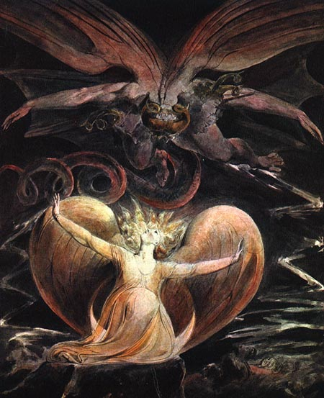
The Great Red Dragon and the Women Clothed with the Sun 1805-1810
William Blake

Valencia College
HUM2310
CRN 27869
TR 2:30 – 3:45
Building 5 Room 114
This class is for three credit hours
Prerequisite: ENC 1101

Professor Bob G. Warren

It would be a good idea for you to take the time to read this entire syllabus. I sprinkle quotes and commentary in the syllabus on purpose. If you come across anything that interests you, ask me about responding in some way. In my class you can help the grades you make on the major assignments (essays), which will be discussed later, by showing an intellectual curiosity and participation with other relevant material; however, there is no independent extra credit given in my class. The focus is on the richness and information you bring to each essay.

“The study of myths – mythology- has a long, rich and highly contested history of debate about exactly what myths are, what they do, and why they are worthy of systematic study. Because of the complexity of such considerations about myths, any short answer to the question ‘why study myth?’ will be, at best, only a starting place. Yet this very complexity is one of the reasons why such study can be so exciting. The study of myth is a field of inquiry that ranges from the earliest known history of humanity up to and including contemporary cultures and societies and even our own individual senses of the self in the world.” Scott Leonard and Michael McClure from their introduction to Myth and Knowing: an introduction to World Mythology

What are we doing in this class?

My focus as a professor is the advancement of critical thinking. This will be measured by the essays you produce, which will take into consideration all aspects of the class materials and discussions. There are many perspectives on the function of mythology, which Margaret K. Devinney and Eva M. Thury in the preface of our text calls “received mythology” from the past, namely mythology that is now essentially connected to our modern conception by the thinnest of threads; yet, we can still trace this thread through our culture in current religions as well as entertainment, art and other forms of narrative. The connection becomes more profound if we concede the possibility that the human mind works, in some way, in a universally recognizable pattern, which is the main approach to myth we will take as a class. We will talk about this in much more detail as we work through our textbook. This will involve many fields, from philosophy, psychology, and anthropology to behavioral science and evolutionary biology. We will be examining and critically thinking about the intellectual history of comparative mythological studies, with the focus being on the progression of critical thinking and essay writing.

You should take notes…and then take notes from your notes, tying together the textbook information with the lecture and other materials. If you are passive and do not think through the ideas in the class, take notes, try to tie the ideas together with the stories, you will not be as successful.

“The Life of a mythology derives the vitality of its symbols as metaphors delivering, not simply the idea, but a sense of actual participation in such a realization of transcendence, infinity, and abundance, as this of which the Upanishadic authors tell. Indeed, the first and most essential service of a mythology is this one, of opening the mind and heart to the utter wonder of all being. And the second service, then, is cosmological: of representing the universe and whole spectacle of nature, both as known to the mind and as beheld by the eye, as an epiphany of such kind that when lightning flashes, or a setting sun ignites the sky, or a deer is seen standing alerted, the exclamation “Ah!” may be uttered as a recognition of divinity.” Question: What, from this quote, is Campbell’s notion of the essential religious experience?
Joseph Campbell from The Inner Reaches of Outer Space

“Song of the Thunders”
Sometimes I,
I go about pitying
Myself
While I am carried by the wind
Across the sky.
(Ojibwa Native American Tribe)
Traditional, translated by Simon Ortiz in his collection of poetry, Woven Stone

“Before the ocean was, or earth, or heaven,
Nature was all alike, shapelessness,
Chaos, so-called, all rude and lumpy matter,
Nothing but bulk, inert, in whose confusion
Discordant atoms warred: there was no sun
To light the universe; there was no moon
With slender silver crescents filling slowly;
No sea reached far along the fringe of shore.
Land, to be sure, there was, and air, and ocean,
But land on which no man could stand, and water
No man could swim in, air no man could breathe,
Air without light, substance forever changing,
Forever at war; within a single body
Heat fought with cold, wet fought with dry, the hard
Fought with the soft, things having weight contended
With weightless things.
Till God, or kindlier Nature,
Settled all argument, and separated
Heaven from earth, water from land, our air
From the high stratosphere, a liberation
So things evolved, and out of blind confusion
Found each its place, bound in eternal order.
The force of fire, that weightless element,
Leaped up and claimed the highest place in heaven;
Below it, air; and under them the earth
Sank with its grosser portions; and the water,
Lowest of all, held up, held in, the land.”
The Opening of Ovid’s Metamorphoses: This is from the 1955 translation by Rolfe Humphries; my personal favorite translation so far.

“…the metaphysical concepts of the archaic world were not always formulated in theoretical language; but the symbol, the myth, the rite, express, on different planes and through the means proper to them, a complex system of coherent affirmations about the ultimate reality of things, a system that can be regarded as constituting a metaphysics.” From The Myth of the Eternal Return by Mircea Eliade

Think about above the quotes. Take some time with them. As you go through the class, your appreciation of the content in each class will shift as you thinking becomes more grounded and coherent.

Email Rules:
I will not answer an email that does not identify your name, the class (prefix and CRN) and the time and the day, as well, of course, the issue, in the subject as a new email, not as an response to anything I have sent you in the class. You should write your email using full grammatical rules and sign it. I will never answer an email regarding material you missed in class due to absence unless we have arranged it prior or you can prove it was an emergency. I repeat, I will not answer email with no prefix, CRN, name, and subject or with questions about what you missed if you were absent without a prior arrangement or proof of emergency, so if you are wondering why you are not getting answers to your email, I will know you have not looked at the syllabus. If there is a credible reason, make an appointment to come by and ask me in person. I will be more than happy to discuss it with you in that manner.

Do not submit assignments via E-mail without prior approval!

Point of interest: Mircea Eliade, the person I quoted earlier, maintained in his own view of religion that the concepts of the spiritual world the more recent concepts of the scientific world are two totally different mental realities. The philosopher Wittgenstein might agree that at least they are different language systems. Eliade did not agree that the myth of the past was a mere attempt to answer the same questions that science now answers. I should note that the editors and authors of our introductory textbook mention this, but they take the far more popular view that mythos (truth/knowledge through narrative) and logos (truth/knowledge through logic) are not mutually exclusive, rather they overlap depending on degree, sometimes being a primitive version of the same kind of mental inquiry on the part of humanity. In other words, narrative about the world would be replaced with logic with the advancement of human inquiry. Thury and Devinney would have no trouble suggesting that a good amount of myth is proto-scientific ways of thinking about the world. Both of these views maintain some merit in comparative mythology, but Eliade’s notion is certainly held by fewer and fewer people, although that does not mean he is incorrect. This means that indeed some of the ancient myth, according to the view maintained in our main textbook, is both narrative as well as proto-science, particularly in the case of Hesiod’s Works and Days and Theogony. We will discuss this in detail. Eliade is typically referring, by using the word archaic, to a way of thinking and a type of human response that may in fact be lost to us and would predate the classical work of Hesiod, Homer, or for that matter any literate myth with which we have access. I realize that this point or discussion may be gobbledygook to you at the moment, but we keep coming back to these ideas as we go through the class.

Office Hours

Professor Warren Office Hours  Bwarren11@valenciacollege.edu ext 1250 Office: 5-248 | Making an appointment is always a better idea, but you are welcome to drop by my office any time I am available.
To be announced soon | If you need to make a special appointment or need to talk to me for any reason, please feel free to approach me and make arrangements.  If I am here, and you have a question of any kind, please feel free to drop in

“We stand upon the foundation reared by the generations that have gone before, and we can but dimly realize the painful and prolonged efforts which it has cost humanity to struggle up to the point, no very exalted one after all, which we have reached…The amount of new knowledge which one age, certainly one man, can add to the common store is small, and it argues stupidity or dishonesty, besides ingratitude, to ignore the heap while vaunting the few grains which it may have been our privilege to add to it…contempt and ridicule or abhorrence and denunciation are too often the only recognition vouchsafed to the savage [in our class we will refer to so-called savage or primitive peoples as primal] and his ways. Yet of the benefactors whom we are bound thankfully to commemorate, many, perhaps most, were savages.” Sir James George Frazer from The Golden Bough:

Required Texts & Materials:

Introduction to Mythology ed. by Eva m. Thury and Margaret k. Devinney 4nd ed. Oxford University Press

Myths to Live By written by Joseph Campbell (Any addition)
Both of these texts are required reading this semester. I will start reading assignments the second class.

Behavior and other rules:

How you could potentially fail my class or be asked to leave and be counted as absent….make sure you read.
You, the student, are responsible for withdrawing yourself, but I may withdraw you no show or fail you for the class for other reasons, depending on the situation; being interruptive, annoying, or disrespectful to your peers or your instructor are all valid reasons. Overtly racist or bigoted comments about sexual orientation, race, gender, nationality, religion or creed, politics, etc, may, upon my discretion, harm your grade and get you counted as absent for the day. If a situation is bad enough to warrant it, you may end up in front of the dean of students. I encourage critical thinking and academic questioning. Legitimate critical thinking is absolutely not considered rude or disrespectful, but it must be done within an academic framework for the purposes of this class’s academic goals. Mere personal opinion, while important to each of us, is not particularly valuable in academics at this level of analysis, though it may help inspire your critical drive. Keep this in mind …we must all work together in the class discussions, and while I want there to be open honest discussion, I do not want you to forget your manners and your ethics when dealing with other people. This is not Facebook, this is not going to be modelled on culture at large, whatsoever. If you do not reflect on the ethics of your approach to social interaction, now would be as good a time to start. When in doubt, feel free to ask. Keep in mind that use of a cell phone to text during class is absolutely forbidden and counts as disruptive behavior in this class. See technology section for more about tech in the classroom.

Attendance and Tardiness:

Every student is expected to attend every class. Students arriving late or leaving early will be documented; two tardy/self-dismissals will result in an absence. Excessive absences mean I can you will fail the course. I will probably leave you in the course and you will simply fail; missing a week or more of instruction in a fifteen-week class greatly reduces your chances of being successful. I reserve the right to fail anyone who misses more than a week and turns in only seventy-five percent of their work, rather than drop you from the class, so please keep this in mind. It is your responsibility to show up for a class and know what is happening in a class. If you have challenges at any point in the semester please bring this to my attention so we can work out what is the best alternative for you as a student. If you are proactive about possible problems, that is much better. Waiting until after there is a problem may end up costing you points or worse, depending on the scenario.

This is a face to face class. All things you miss in class are your responsibility. Assignments are announced in class, not on Canvas. I will email you assignments and I may engage with Canvas some, but this all assignments are given and clarified in class, not on canvas. All grades are given back to you and it is your responsibility to keep track of your grades; I will not do that for you.

“We [empiricists] never prove a theory right; we merely fail to prove it wrong.” Karl Popper

Other class protocol: You may lose points, be counted as not present, be asked to leave if you do not keep these rules in mind. What I will do is at my discretion.

- Please avoid getting up in the middle of class to use the restroom, make/answer a call etc., unless you have a medical condition documented in writing by the OSD. If we watch a documentary, you may not go to the restroom unless it is an emergency, or you may be asked to stay outside, wait till the documentary is over and be counted absent.

- There will be NO general NEED, for you to have an iPod, recorder, phone, or computer (laptop) in class. IF YOU PLAN TO USE A LAPTOP, YOU BETTER ASK FIRST. I make exceptions for anyone that turns in a contractual understanding that is signed and dated about tech usage. This contract should state that you understand that you are to only use tech for the sole purposes of taking notes in class and that you understand that if you are caught doing something else, you automatically may fail the class outright. Write the above understanding on a piece of paper, then sign and date it and turn it into me. The only way this will be altered is if you have paperwork from OSD that requires you to use technology.

This contract must be turned in before you use any technology.

- The contract you must type up or copy/paste, then date and sign:

I (insert your name) understand that I am using technology for the sole purpose of class while in class. This means only for note taking purposes or as directed in class specifically. If I use technology for any other reason, I realize that I could fail the class outright. Date: Signature: Print Name: Vid#

- Please turn off or silence all cell phones BEFORE you get to class. Also, avoid using other smart tech such as smartwatches to text or keep track of texts while we are in class.

- Having your phone in your lap, on your desk, hidden in a book bag, behind a book bad, in a pocket in a bag, satchel, whatever it may be, under the desk…etc. These are all disruptions in my class and illegal moves. I think you get the point.

- If there is a reason that you desperately need to have your phone on alert, you need to show evidence or have a good reason that you tell me about before it happens…in that case you should have your phone gently on vibrate. This would have to be a special occasion or situation.

- Falling asleep = absence. See above policy. If you fall asleep, you may be asked to leave the class. While this behavior may or may not get you withdrawn, it will result in a reduced grade.

- No outsiders are allowed in the class that are not enrolled in the class…friends, family, etc, cannot attend the class. They are not enrolled in the class.

- Students with disabilities/special needs should contact me with OSD forms for appropriate adjustments and/or accommodations in class. This is up to you. If you do not inform me that you have special needs, I officially do not know and do not have to accommodate you. I will try of course, but I need to know what you need to make the class work for you.

- Baycare Behavioral Health’s Student Assistance Program

Include this statement, which is useful to students in need of private counseling:
“Valencia is committed to making sure all our students have a rewarding and successful college experience. To that purpose, Valencia students can get immediate help that may assist them with psychological issues dealing with stress, anxiety, depression, adjustment difficulties, substance abuse, time management as well as relationship problems dealing with school, home or work. Students have 24 hour unlimited access to the Baycare Behavioral Health’s confidential student assistance program phone counseling services by calling (800) 878-5470. Three free confidential face-to-face counseling sessions are also available to students.”

Other important things to keep in mind:

If you miss a class, it is YOUR responsibility to know what you missed and to make up the work. If you miss: I mentioned this earlier, but it cannot help but repeat….DO NOT CONTACT ME THE NEXT DAY AND ASK WHAT YOU MISSED!!!!

✓Notes and discussion: get highlights from a classmate; please do not count on me to fill you in.
✓ In-class activities: Only students who are PRESENT count.
✓Turning in an essay/written assignment: These papers must be submitted in person and at the start of class on the day they are due, UNLESS I SAY DIFFERENT. Any assignment turned in after this time will likely lose points. If you know you will miss one of these days, turn it in early in class, or turn it in to the Fine Arts Office, 5-146, to have it time/date stamped and put in the appropriate mailbox…just tell them my name. If these options are impossible, you must get permission FROM ME, BEFORE THE DUE DATE, to send your assignment(s) via Atlas. I do not use blackboard at this time. Do not leave work anywhere else, especially under my office doors.

All late work is subject to losing a letter grade at my discretion (10%) per day, including weekends. I do take into consideration that life is not fair and that things can get in the way, but it better be good. I sometimes have to follow these rules, but in the end I try my best to facilitate your learning.

Course Requirements & Grades:

My rubric is professionally subjective in relation to the topic, grammatical in the sense that you either clearly communicate or not, and stylistic in the sense that you have a thesis and support it, but if you are eloquent while doing so, even better. Every support of your thesis is subject to point loss. Your thesis is subject to point loss, your conclusion is subject to point loss.

Here is the breakdown:
100% = A
Thesis = 30%
Body (support) = 30%
Conclusion = 30%
Grammar and style = 5% (If grammar clouds the thesis, body, Conclusion, etc., in a way that makes your paper impossible to understand, then you may still lose points in those areas if grammar is bad enough. This 5% ONLY REFERS TO: Comma splices, Fragments, run-ons, misused semi-colons, verb tense shifts, subject verb agreement, and titles properly addressed MLA if used, etc. If all of these above aspects are running badly though it could easily change the way in which the other parts of the paper work and will bleed over into that aspect of the grade.) MLA must be used though. No citation of materials used results in a 0. Each different prompt will have the requirements of what you should have in your thesis, body, and conclusion.

Properly finished (stapled, class info, etc.) = 5% You come to class with the essay stapled, no folding corners, tearing corners, etc., although I will take paper clips. NO FOLDERS OR JACKETS ON THE ESSAYS, the thought is nice, but it simply a waste of money, material, and the cases slip around and are annoying when in a stack with other papers.
Total = 100%

This is the basic rubric by which I will determine the grade of an essay. I will comment on each aspect of your essays. Since I am not teaching this as a composition instructor, I will be focusing my rubric on the four main aspects mentioned above: 1.Thesis construction 2. The Body paragraphs, specifically the effectiveness of your support, must work in conjunction with your thesis 3.Conclusion paragraph 4. Do you effectively use MLA to show from where you information comes. This is essential, and if you do not remember you absolutely must understand what parenthetical documentation is. You must understand this, look it up, go ask about it at the writing lab, but it is essential to tell your reader on what authority you back up your thesis, and that requires you understand MLA rules.

Each paper’s length is subject to change, though there will be an average length on most papers of four pages double-spaced. I accept a maximum of fifty pages per essay in case you are a budding writer and would like to try to go for a larger more ambitious work, but generally I will give you a max…so if you do want to go to extremes in length, please see me personally. I support you in that, but make sure, if the paper is that long, that you have some idea of what you are doing, and please talk to me about your intentions before committing to a length of that nature.

I do look for proofread papers that strive to communicate ideas with an eye towards analysis. Though I stress that the ultimate source of your analysis is you, the student, you must rely on supporting evidence from the analytical tools as well as the primary source material for your opinion to retain any validity. In many ways you will be constructing a point of view out of preexisting ideas, but this is natural. You are students, non-professionals at mythology, etc., and there will be times when you merely need to show you understand. Novel thesis ideas are far and few in between, and must be supported with evidence, but if you think you have a novel idea, come see me and let’s find out. For you it is important to understand this is an exercise; this is school, this is not a professional paper because you have no authority on your own, which means that support is non-optional.

In other words, though I respect you as students, and I respect your opinions in general, I cannot accept your opinion academically unless you understand how exactly you have come to have your opinion and why you can have your opinion. This takes some amount of research and reading, taking clues from the class and the textbook, and any further reading you may elect to do on your own. I always can suggest further reading on many topics.

Grammar may not be stressed, but it will be noticed if sloppy and bumpy when I am reading the paper and certainly if your grammar or your style is particularly bad, this will be reflected in your grade. When in doubt, go work on your skills in the writing lab, though please do not expect them to do your proofreading; they are there to help you help yourself with grammatical and conceptual difficulties, not to proofread.

No, how do you know that you are fulfilling the thesis, body and prompt? For that you must consult the prompt that I give you and make sure to fulfil the expectations in terms of focus, content required, and the specific aim of the prompt. Keep in mind that at no time in this class will I ever be interested in plot summary as a means to explain your perspective. Plot can be used, but only as a means to illustrate what you, the author and analyst, are attempting to point out.

For the purposes of this class, these are academic essays that are meant to be informed analytical papers. You will not assume I have no knowledge of the subject as reader, quite the opposite. You will assume that we share the general knowledge and focus on explaining and analyzing in order to illustrate you understand the content of the tools, like the monomyth, the arches of creations, archetypes, symbolism, interpretation, etc.

Revision Policy:
Within two weeks of getting your essay back, if you feel you want to revise it for a better grade, or just to promote better writing, you have two weeks. Please do not push me on this. You may not revise a paper unless you meet the minimum requirement.

*Please turn in the previously graded paper with the revision.
Response papers, in-class work and the research paper, if there is one, MAY NOT be revised.

Academic Dishonesty:
Quite simply, all work that you turn in MUST be your own, original work. Any and all outside sources MUST BE documented, or you are committing plagiarism, an offense punishable by a failing grade on the assignment and/or a failing grade in the course. Ignorance of MLA citation is no defense; even inadvertent plagiarism subjects the writer to these consequences. Note that MLA is now in its seventh addition and many aspects have changed, which you should look up if you are in doubt.

Plagiarism is unacceptable
All work submitted for credit in this class must be the product of the individual student’s own original thoughts supported and informed by appropriately documented and credited sources. Plagiarism is the use of someone else’s words, ideas, pictures, design, and/or intellectual property without the correct documentation and punctuation.
If you so plagiarize, you risk automatic failure of the assignment and possibly the class, depending on how serious the problem.

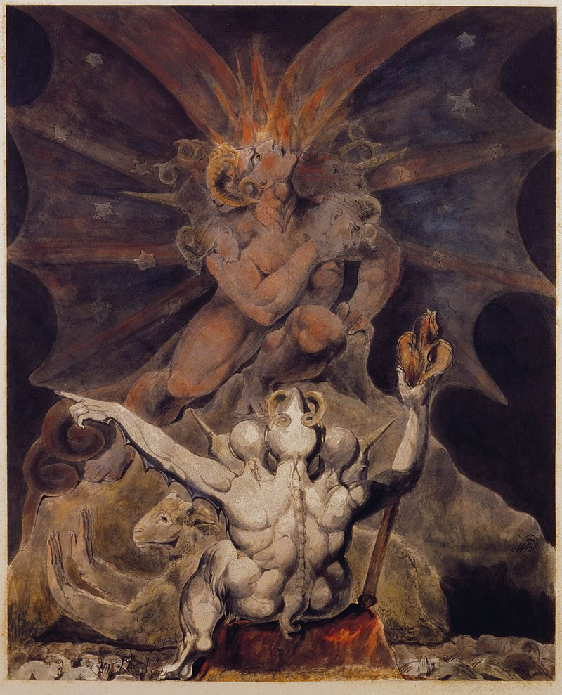
The Number of the Beast is 666 1805-1810 William Blake

Format for assignments:
All assignments written outside of class need to be word processed.

The Four Main Assignments
The four main essays are equally 23.75% of your final grade, which may or may not be further affected by other factors mentioned in this syllabus. Each essay follows the section of lecture within that period of the class and will be using all the relevant information in their construction. 5% is attendance. Keep in mind that behavioral issues and extra credit can be added to any of these percentages, which includes reading quizzes that will sometimes be counted in class. The topics are subject to change from time to time, but they will still touch in some way on one of these broad topics.

Essay One: The Monomyth, philosophy and psychology
Essay Two: Creation Mythology and the Emergence of Mankind
Assignment Three: The Rite of Passage, Ceremony, and Ritual and psychology
Assignment Four: Modern to Contemporary narratives and Mythology

Specific and well detailed prompts will be provided to you as we get within two weeks of each essays due date, as that is the time I allow you to construct each writing.

One last point:

Implicit in this class is a historical-critical, and philosophical approach to religious matters in keeping with academic standards. We are also going to look through the lens of influential ideas and concepts at human artifacts, which you may not agree with or enjoy. Your agreement is not necessary, nor is your disagreement. We are only trying to expand our thinking about these matters. This method often precludes devotional understandings for the purposes of the class, or to use other words, dogmatic, orthodox or fundamental understandings of a religious text or the world through one lens. Though your religion is important to you, it is not essential to this class, nor is devotional understandings adequate as a form of academic analysis. Comparative mythology is not about devotion, it is about analysis. I am not asking you to not have personal opinions or beliefs of course, but I am insisting that to write in relation to your already held convictions is self-serving and not critical thinking. You do not have to agree or disagree, you merely have to understand and communicate. It is likely that you will be faced with ideas that are both strange and perhaps even disturbing, but that is partly what learning is about. When we study mythology, no system is above or better than another, they are all biological, cultural, social, evolving constructions in terms of the course.

To put this matter another way, we are in no way debating or even considering the question, “Is there a God?” If we do consider this question it would only be imaginatively and in context rather than a striving for proof. Mythological systems evaluated in the manner in which we are, academically, are held as texts, works of literature and history that are held to the analytical techniques of literature, anthropological and historical documents. The culture is a social structure, and as such, the comparative study of mythology is dealing with what can be known, what can be said, and what science can be brought to the table is relevant as well, as long as it is good science, empirically grounded and falsifiable. The metaphysical concept of “God” or “god(s)” is part of a mythology culturally discussion, but proof of God is neither testable, knowable, nor falsifiable in terms of scientific inquiry. It is part of a rich heritage metaphysically, but knowing how to talk about it is essential in academic terms.

Disclaimer:

Anything in this syllabus may be changed by the instructor. Any changes will be made in class and/or via Atlas. Students enrolled in this class after the drop/refund deadline AUTOMATICALLY accept and agree to abide by this syllabus. It is my discretion to allocate failing grades, ask students to leave, or drop any student that causes trouble for the class as a whole and refuses to abide by class rules.

“Consciousness is the aspect of our humanity that is most obviously – and famously – incompatible with reductionism; it is seen by many as our best evidence, indeed for some proof, of the existence of a Creator God. It there is a soul, we tend to think it is located in consciousness or synonymous with it. Thus when the Catholic Church recently embraced the theory of evolution, it was careful to restrict its endorsement to the evolution of the body, not the mind.” Stuart A. Kaufman’s Reinventing the Sacred: a new View of Science, Reason, and Religion

What about this critical comment from the late great Alan Watts?
“Man’s biological unity is merely an instrumental unity. All have the same instruments, but their life consists in what they do with them. Thus to be united in action we must agree about ends, which means that we must agree philosophically. To agree to differ, to let everyone follow quite independent or contradictory views of man’s end, is merely to agree not to have any true social union, and to let our society disintegrate spiritually as it is in fact now doing.”
Alan Watts The Supreme Identity: An Essay on the Oriental
Metaphysic and the Christian Religion

“Madmen they all seem to me, clambering monkeys and overeager. To me their idol smells foul, the cold monster: to me they all smell foul, these idolaters… when Zarathustra was alone, he spoke thus to his heart…God is Dead.” Friedrich Nietzsche Thus Spoke Zarathustra

A list of related work about science, religion, and myth, as well as topics dealing with Myth’ and religion in some cases, that you may read, just let me know what you are doing if you want this work to reflect your final grade average of the essays at the end of the semester. Sometimes several titles are mentioned. I will add to this list in class and I welcome inquiry into these topics, so feel free to ask. Anytime feel free to ask me about source material and academic material about any aspect of our course. Some of these titles are skeptical works about belief and religion. They are on this list to provide alternative perspectives on the subject of belief. I will add more as the course goes on from time to time. I do not suggest any of these books are correct or my own opinion, but they are influential and interesting to consider.

- Stuart A. Kaufman Reinventing the Sacred
- Bart Ehrman Misquoting Jesus, Jesus, Interrupted, God’s Problem
- Daniel Dennett Breaking the Spell: Religion as a Natural Phenomena, Consciousness Explained, Elbow Room, Freedom Evolves, The Mind’s Eye w/ Douglas Hofstadter, Brainstorms, Darwin’s Dangerous Idea
- Stephen Pinker The Language Instinct
- Lakoff and Johnson Philosophy in the Flesh
- Harold Bloom The Lucifer Principle
- Guy Murchie The Seven Mysteries of Life
- Joseph Campbell The Masks of God Series (4 part book series), The Hero with a Thousand Faces, The Inner Reaches of Outer Space, The Mythic Image, The Power of Myth book
- Maya Deren Divine Horsemen: The Living Gods of Haiti (forward by J. Campbell)
- David Carrasco City of Sacrifice: The Aztec Empire and the Role of Violence in Civilization
- Mircea Eliade The Myth of the Eternal Return, The Two and the One
- Sir James Frazer The Golden Bough (any part as the whole is long)
- Ed. James M. Robinson The Nag Hammadi Library
- Elaine Pagels The Gnostic Gospels, Beyond Belief: The Gospel of Thomas
- John Lindow Norse Mythology: A Guide to the Gods, Heroes, rituals, and Beliefs
- Ed. Murford and Lenardon Classical Mythology
- Trans. by Jane Smiley Sagas of the Icelanders (Must be the Smiley translation)
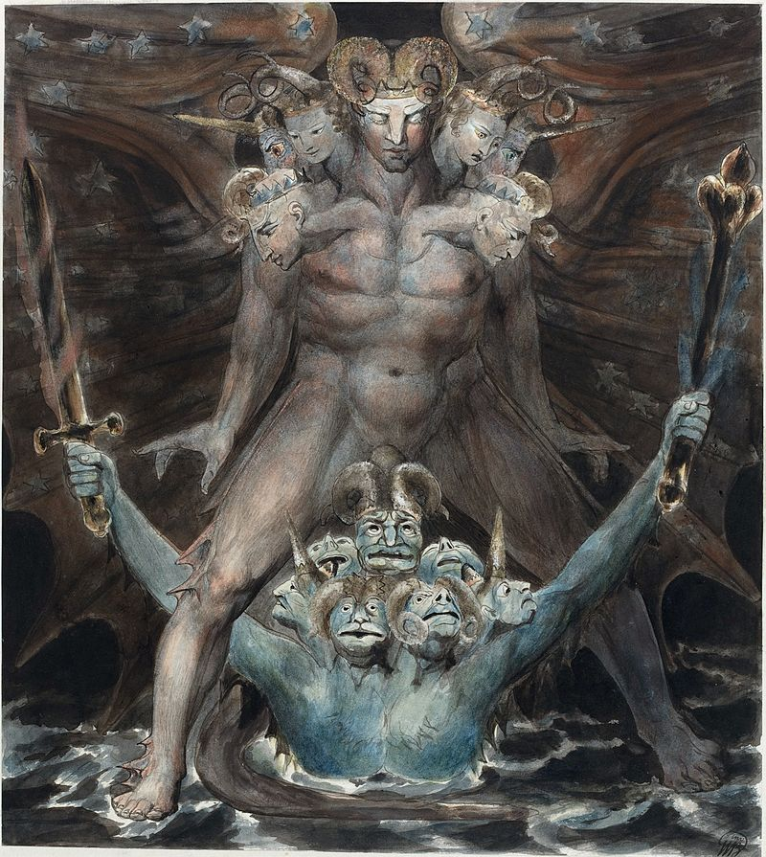 The Great Red Dragon and the Beast from the Sea 1805-1810 William Blake

I reserve the right to cchange anything in this syllabus if the need arises and it makes rational sense for the purposes of the class.

